The Industrial Revolution in the United States
(approx.1865- 1900)

Describe the United States in 1800 prior to the Industrial Revolution.

________________________________________________________________________________________________
________________________________________________________________________________________________
________________________________________________________________________________________________

How had the United States changed after 1860?

________________________________________________________________________________________________
________________________________________________________________________________________________
________________________________________________________________________________________________
________________________________________________________________________________________________

Daily Life: Indoor electric lighting did not exist until 1865. Instead the rising and setting of the sun dictated the rhythm of a day’s work. Think about summers without the benefits of refrigeration! Ice was available in 1865, but only at a great cost. Long-distance communication was agonizingly slow. In 1860 mail from the East Coast took 10 days to reach the Midwest and three weeks to get to the West Coast. Mail from Europe could take several months. By 1900, this picture of daily life changed dramatically for millions of Americans. The post-Civil War years saw tremendous growth in new ideas and inventions.

Who was the “father of the American Industrial Revolution”?
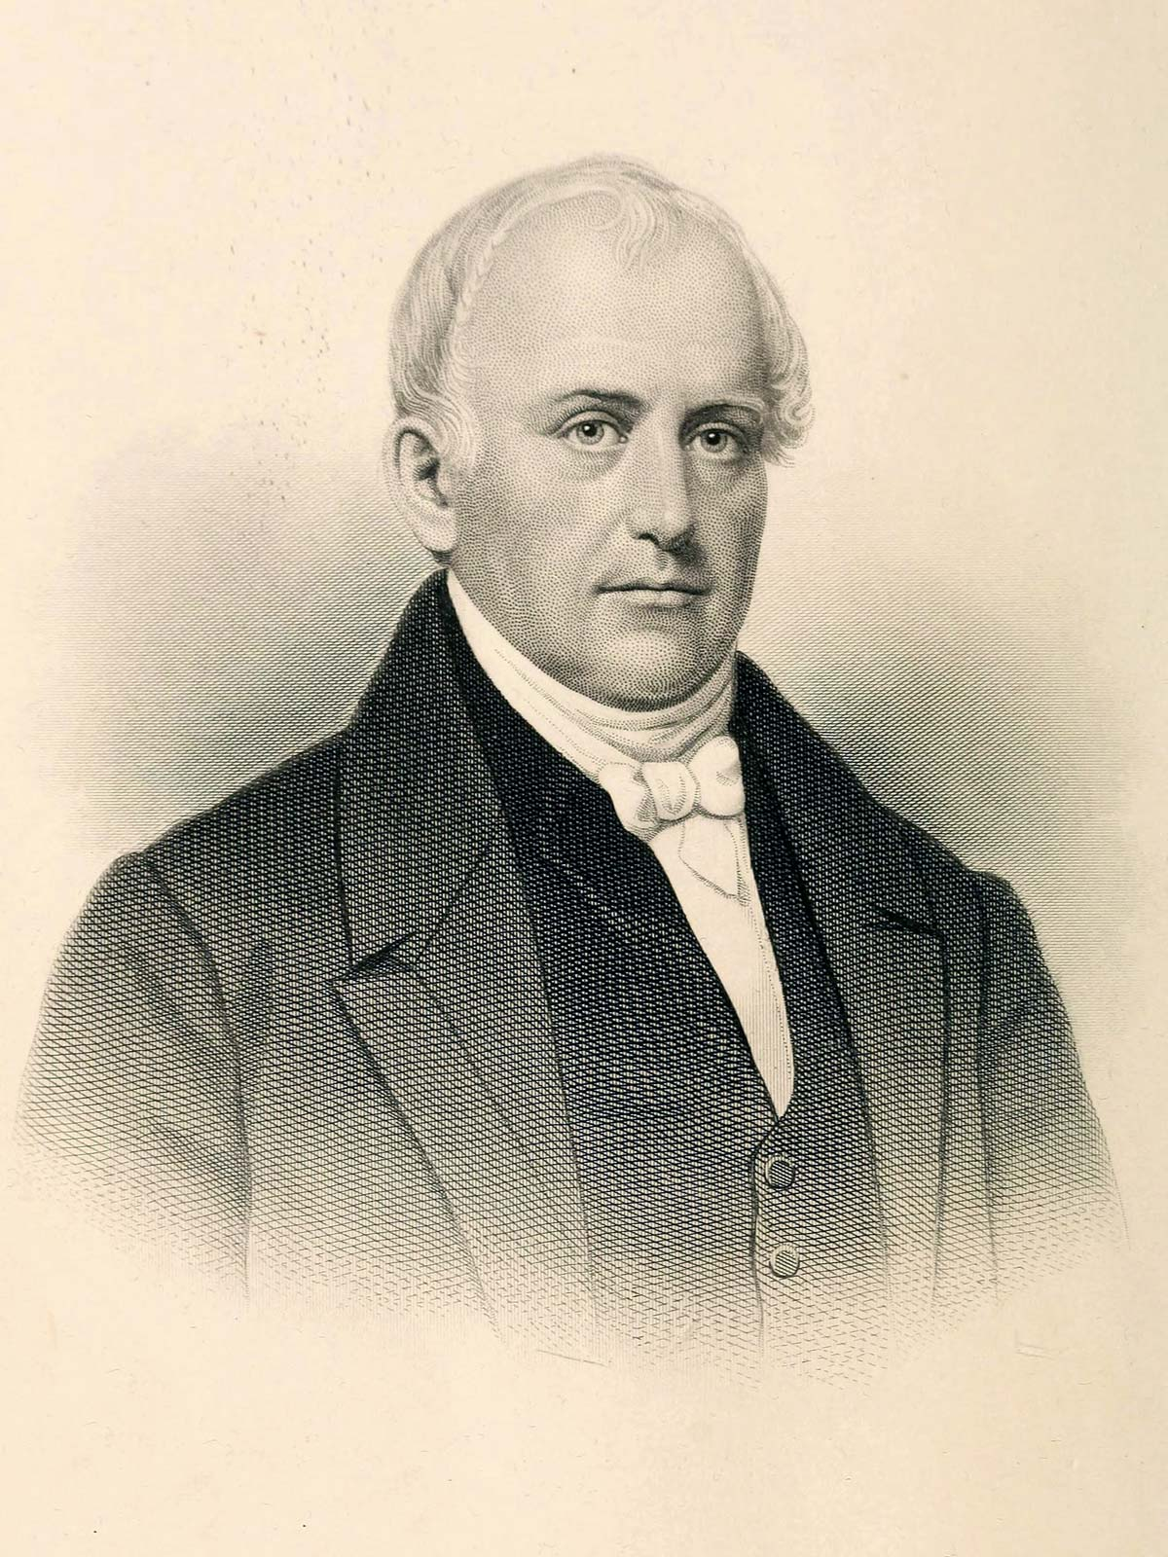

To protect its industrial advantage, the British _______________________________ ________________________________________, as well as emigration of workers with knowledge of the technology. However, a skilled worker defied law and moved to the United States. His name was _________________________________ (pictured left). He established the first textile factory in 1790 using water-powered spinning machines in Rhode Island.

Encouraging Industrial Growth: What five factors spurred industrial growth in America?

Several factors led to the growth of industry in the United States.

- ______________________________
- Challenged industries to make goods more quickly and efficiently
- Using new tools and methods, factories stepped up production of guns, ammunition, and uniforms.

- ______________________________
- Numerous coal mines along the eastern seaboard helped power steam engines in trains and factories
- thick forests were cut into lumber for construction

- _______________________________
- following the Civil War a large number of Europeans immigrated to the United States
- In 1881 alone, nearly three quarters of a million immigrants arrived in America.
- By 1905 the number of immigrants reached ____________________________.

- _______________________________
- The heroes of this system were entrepreneurs who fueled industry in America through the railroads, mines, and factories.
- In 1868, Horatio Alger published a novel, Street Life in New York, that told the story of a poor boy who rose to wealth and fame by working hard. The novel was wildly successful and stressed the possibility that anyone could __________________________________________________.

- ________________________________
- For example, to encourage the buying of American goods, Congress enacted _______________
___________________________, or taxes that would make imported goods cost more than goods made locally.
- Millions of acres of land was given to _________________________________ freely in return for their promise to quickly link the East and West coasts.
- The government also encourage _________________________________________ allowing businesses to operate under minimal government regulation.

Innovation Drives the Nation

By the late 1800s, the drive for innovation and efficiency seemed to touch every aspect of life. The mid to late 1800s were marked with several major inventions.

 | Year | Invention | Inventor | Importance
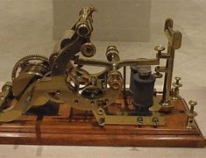 | 1844
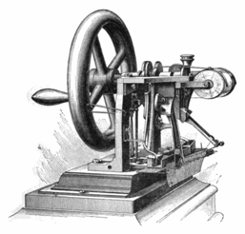 | 1846
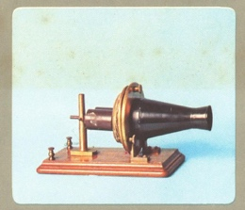 | 1876
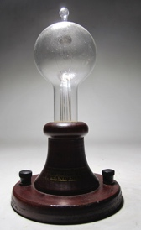 | 1880

The Need for Transportation

- Why was transportation especially important to the United States?

- What two modes of transportation emerge during the Industrial Revolution?

The Railroad

  - The 1st Transcontinental Railroad was completed in 1869, a railway extending coast to coast.

  - It was known as the “Pacific Railroad.”

  - Within 25 years, _______________________________ connected the East and West coasts.

- The meatpacking industry relied heavily on the railroad for transporting livestock and products. In

1877, Gustavus Swift developed __________________________________ to transport food.

  - Railroads created a need for ______________________________________ in 1884.
    - Throughout much of the 1800s, most towns set their clocks independently according to solar time, but this created confusion. The railroads adopted a national system of time zones to improve scheduling. As a result, clocks in broad regions of the country showed the same time, a system still used today.

    - 4 time zones were established in the United States: ___________________________________,

_________________________, _______________________, and _______________________.

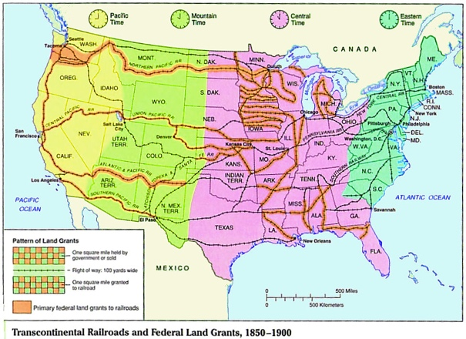

- Railroads played a key role in transforming American industries and businesses. They could transport a large amount of goods and people __________________________, _________________________, and __________________________________.

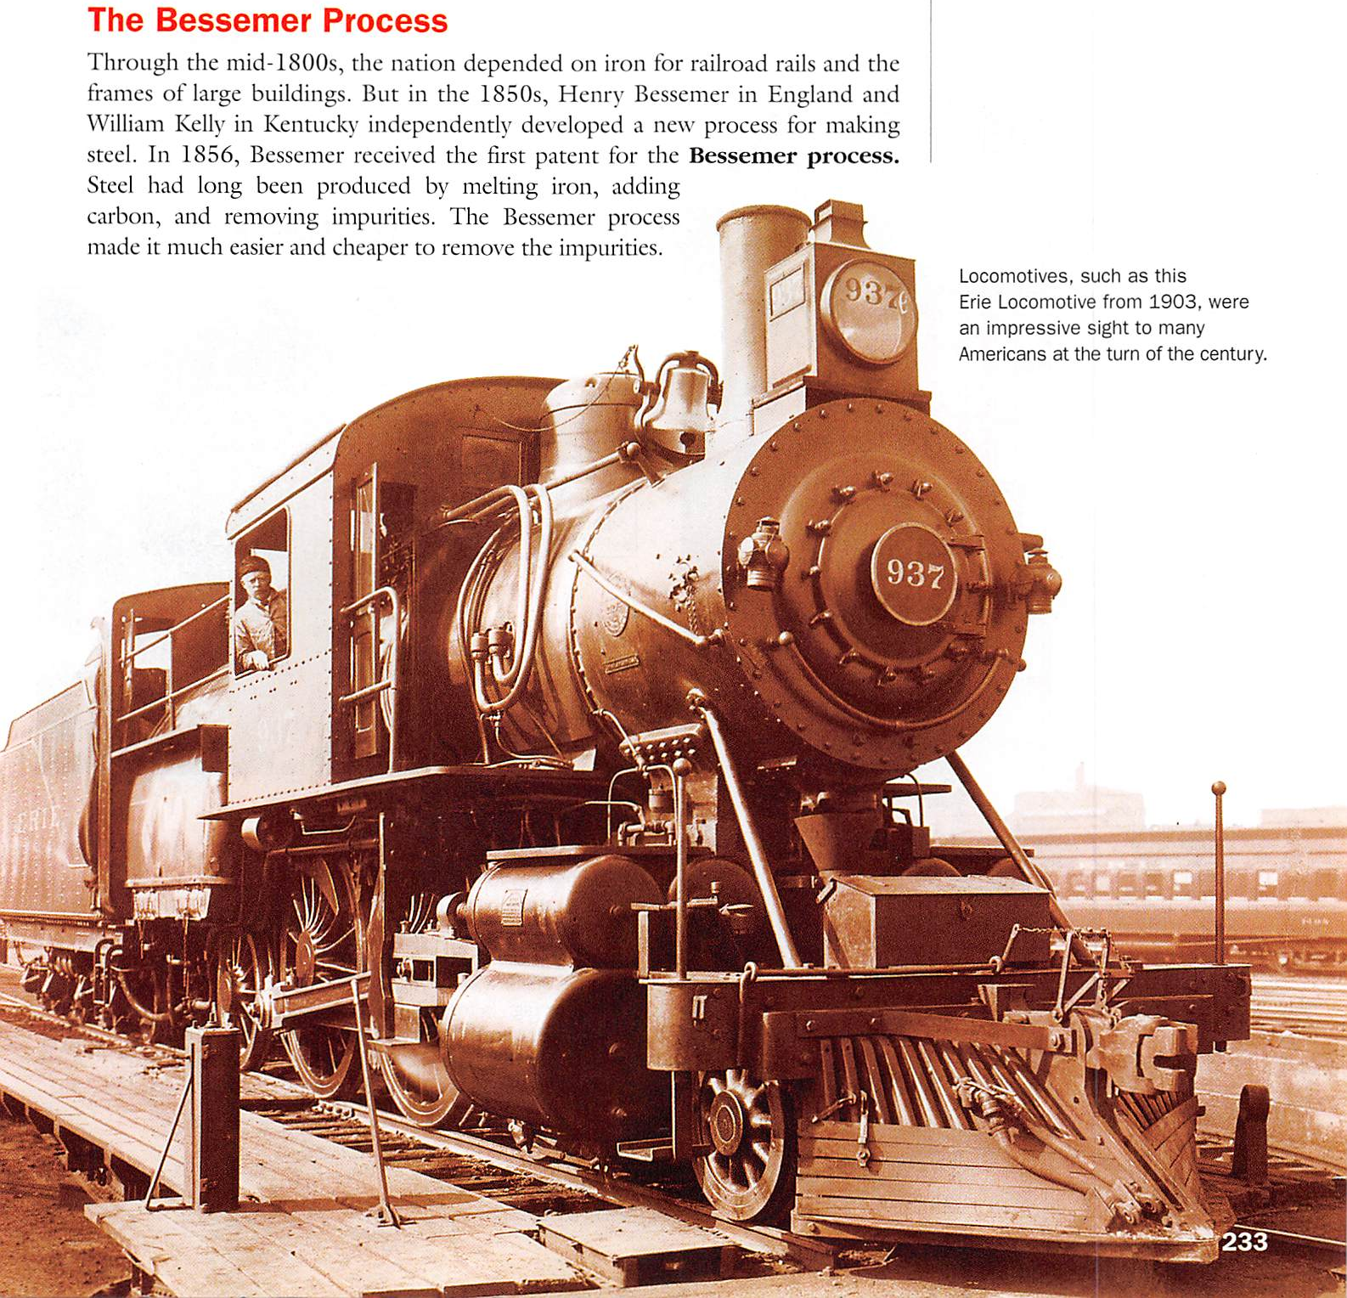
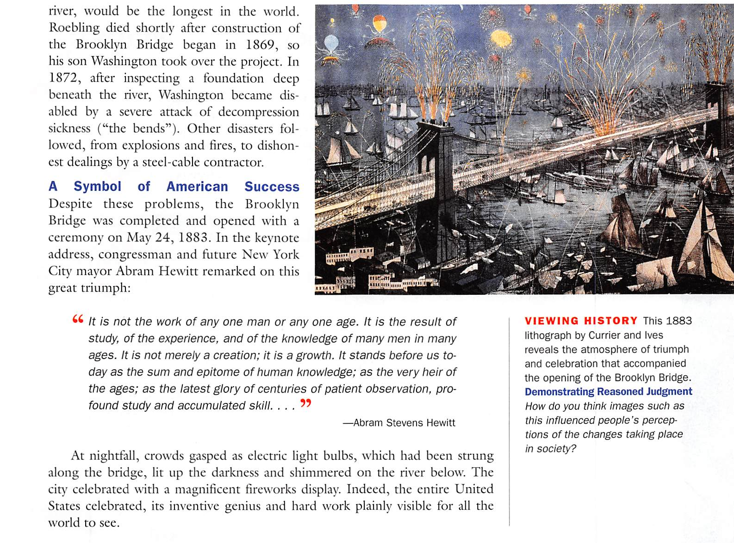

Effects of the Industrial Revolution
Study the chart below and summarize each section in the space on the right demonstrating knowledge of the effects the Industrial Revolution had on the economy, society, and politics.

The Rise of Big Business in America
How did big business shape the American economy in the late 1800s and early 1900s?
Review
- Rapid industrial growth that occurred after the Civil War transformed American business and society.
- Until the mid-nineteenth century, most businesses were run by one person or one family. Businesses could only grow was big as one family had the ability to invest or run it.
- Businesses were local, buying and selling to customers who lived nearby.
- Industrialization and the railroad changed all this!
The Corporation Develops
To take advantage of expanding markets, investors developed a form of group ownership known as a ________________________________.
- In a corporation, ______________________________________________________________________
____________________________________________________________________________________
- If a corporation experiences economic problems, ___________________________________________
____________________________________________________________________________________
- The corporation was the perfect solution to the challenges of expanding businesses and had the same rights an individual owner:
  - ______________________________________________
  - ______________________________________________
- Corporations had access to larger amounts of capital, or _______________________________, allowing them to
  - _____________________________________________________
  - _____________________________________________________
  - _____________________________________________________
- Corporations worked to maximize profits.
- Decreased Costs
    - _________________________________________________________________
    - _________________________________________________________________
- Increased Profits
- _________________________________________________________________
- _________________________________________________________________
- Structure of a Corporation

Role | Job/Responsibilities
Public Shareholders
Board of Directors
Managers
Employees

- Some corporations tried to gain a ____________________________, or complete control of a product or service. To do this, a corporation either ____________________________________________ or _______________________________________________. Once consumers had no other choice for a given product or service, the sole remaining company____________________________________________________
__________________________________________________________________________________________
- Other corporations worked to _________________________________________________________ by forming a ______________________________. In this arrangement, businesses making the same product
____________________________________________________________________________.
Horizontal and Vertical Integration
- Horizontal integration
  - ______________________________________________________________________________
______________________________________________________________________________
  - A company may do this __________________________________________________________
______________________________________________________________________________
  - Can lead to a ______________________ if a company captures the vast majority of the market.
  - Examples:

- Vertical Integration
  - ____________________________________________________________________________________________________________________________________________________________
______________________________________________________________________________
  - Allows companies to _____________________________ and ____________________________ to competitors.
  - Examples:

The Captains of Industry
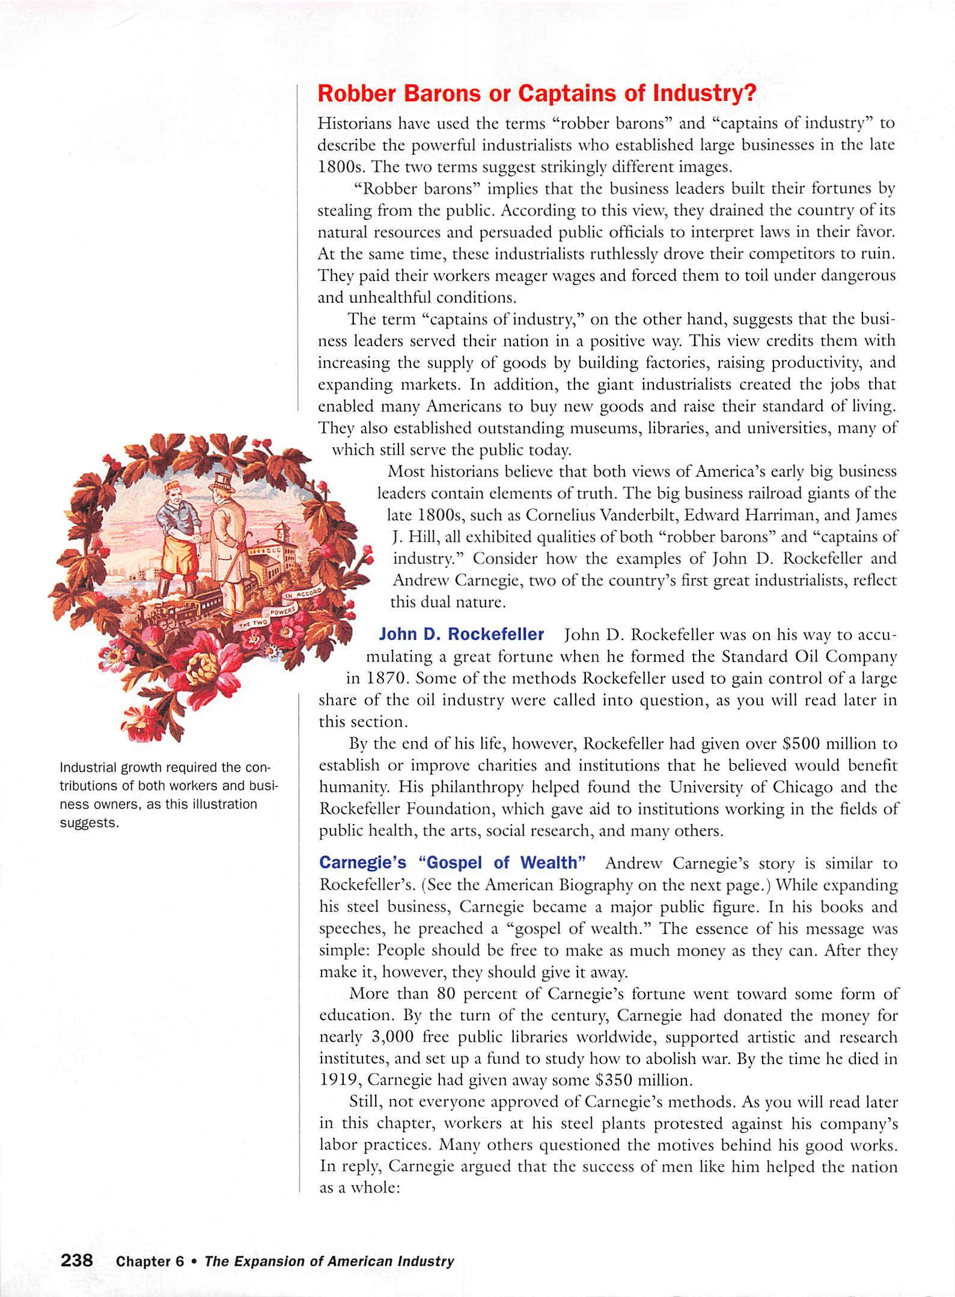
Reading Check

Distinguish between the terms “robber barons” and “captains of industry”.

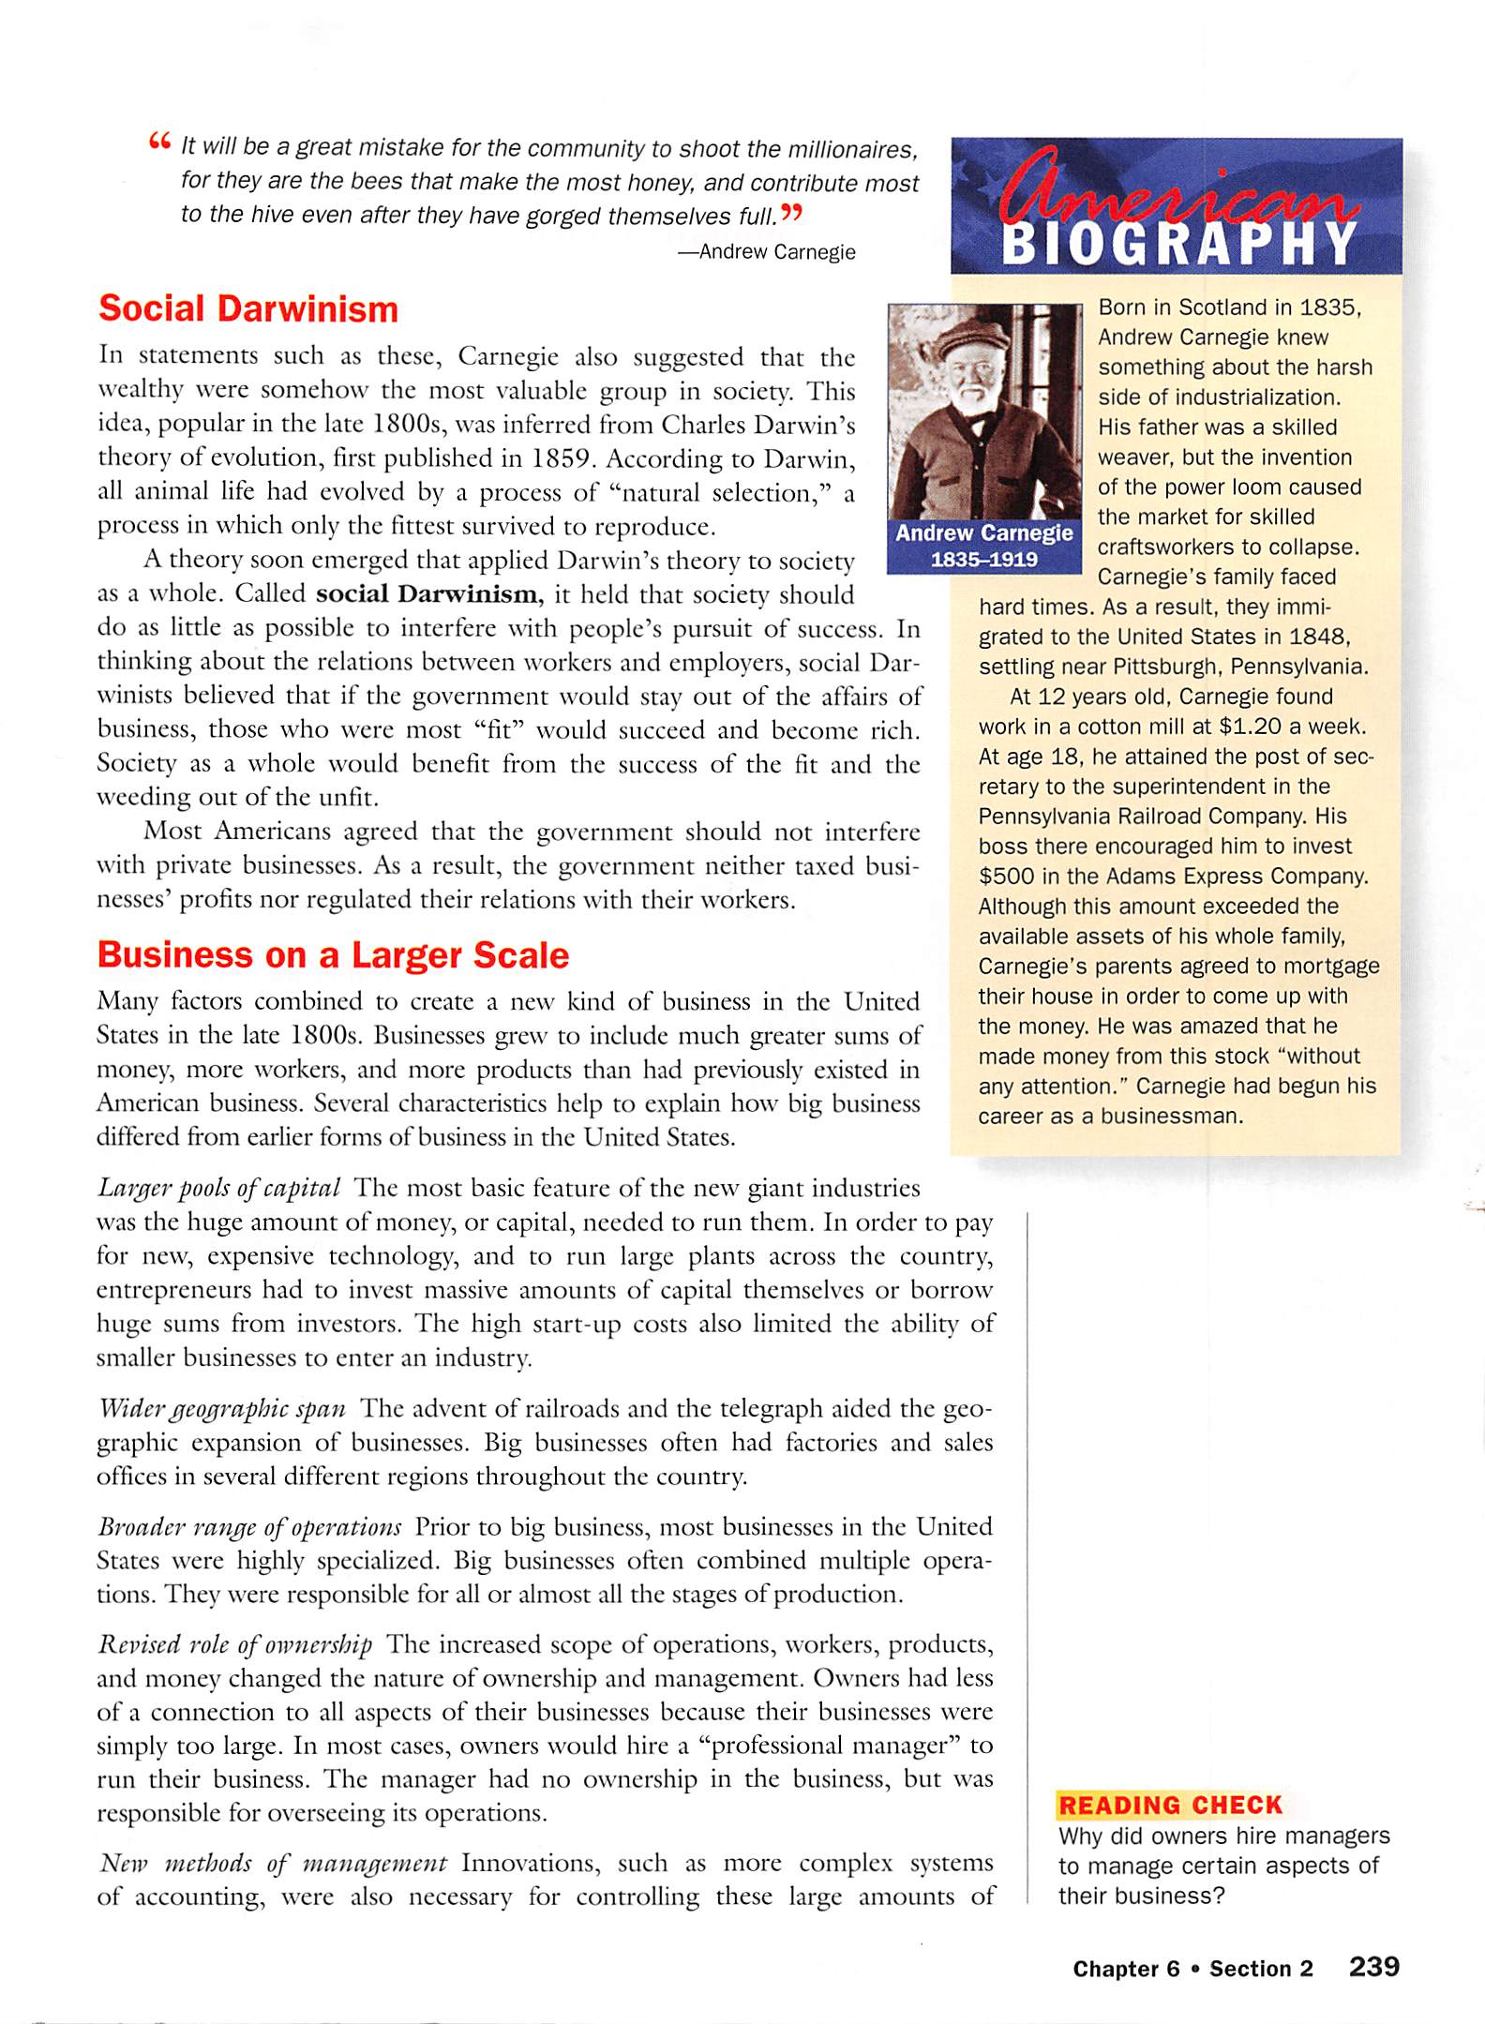
Reading Check:
Define social Darwinism.

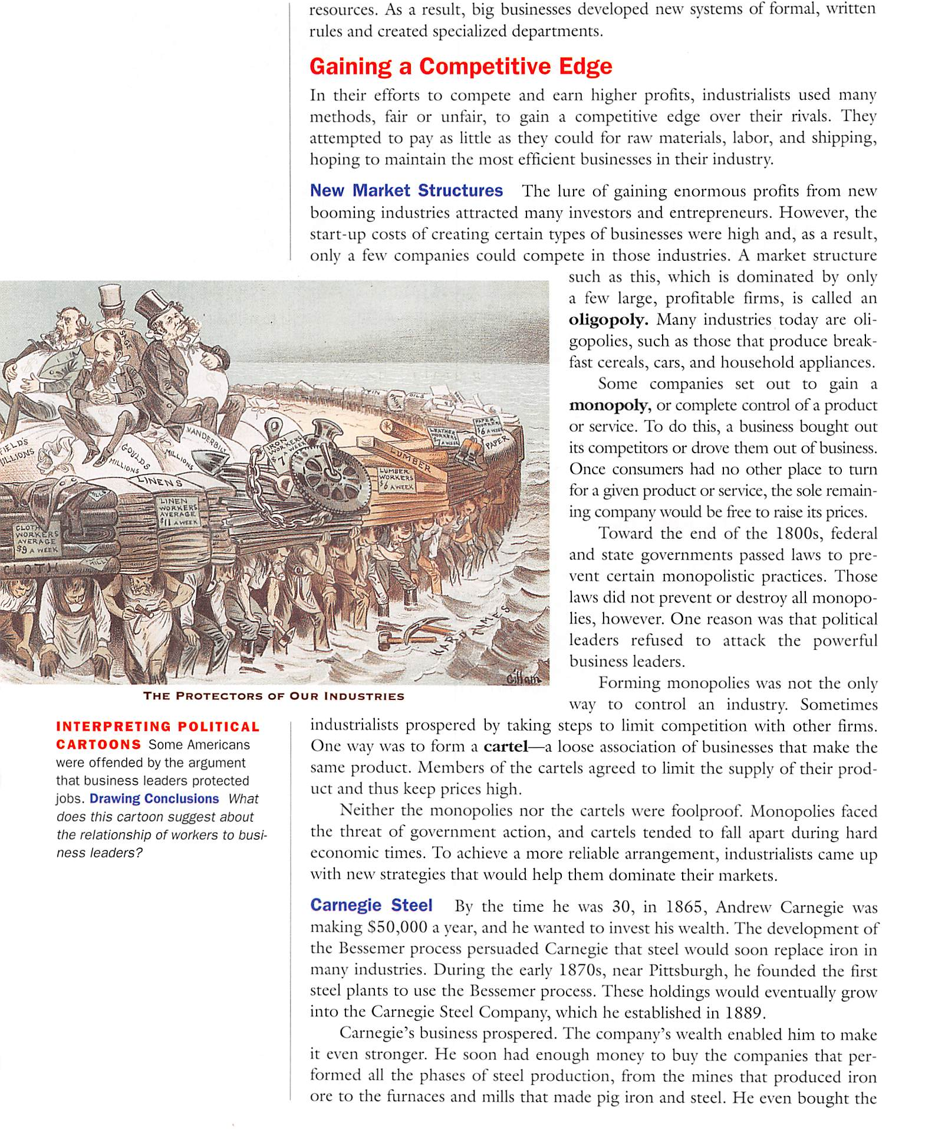
Reading Check

Define oligopoly, monopoly, and cartel.

How can Rockefeller and Carnegie be considered both a “captain of industry” and a “robber baron”?

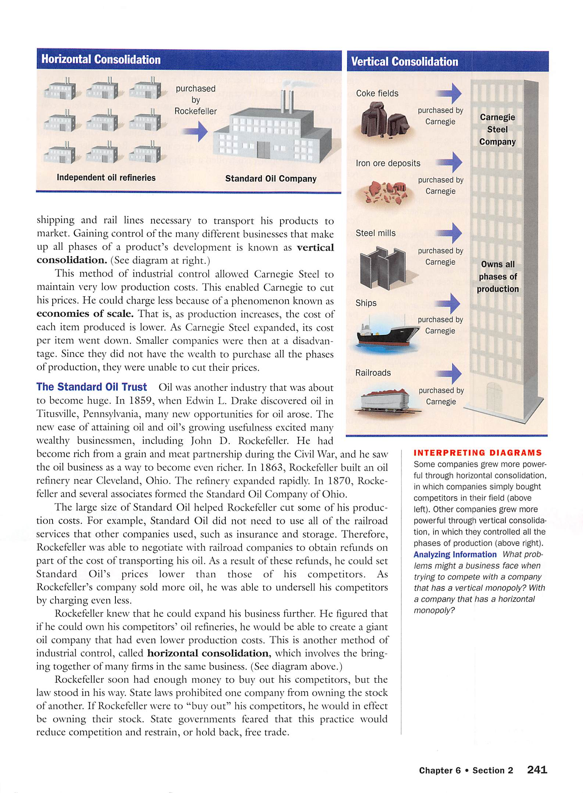
The Sherman Antitrust Act
  - It became the first federal act to __________________________________________________ in order to curb concentrations of power that interfere with trade and reduce economic competition.
  - It was named for U.S. Senator ________________________ of Ohio, who was an expert on the regulation of commerce under the presidency of _____________________________ in 1890.
  - The language of the Sherman Antitrust Act proved difficult to enforce. It was, however, successfully enforced in one notable case. In 1906, the federal government charged the Standard Oil Company with violating the first two sections of the act. Standard Oil appealed and the case was ultimately decide by the Supreme Court which upheld the conviction. (See Handout)
  - In 1914 Congress passed the _____________________________ to clarify the Sherman Act.
- The Clayton Act
  - The Clayton Act_______________________________________________________________
____________________________________________________________________________
____________________________________________________________________________
  - The act also said businesses could not buy stock in other corporations in order to reduce competition.
  - The act also addressed the control of companies by outlawing ___________________________ - a circumstance in which the_____________________________________________________________
__________________________________________________________________________________
In the same year that the Clayton Act was passed, Congress established the __________________________________ ____________________________ (FTC).
- The Federal Trade Commission
  - The FTC is an independent regulatory agency established to carry out the provisions of the Clayton Act. The commission may define ___________________________________________, _______________________________________, _____________________________________, _______________________________________________.
  - Today the FTC has many responsibilities in addition to enforcing the Clayton Act. These responsibilities include:
    - ___________________________________________________________________
    - ___________________________________________________________________
    - ___________________________________________________________________
Enforcing the country’s antitrust laws is the responsibility of the _____________________________________________
_________________________________________________________________________________________________.
The Progressive Era

________________________________, ______________________________, and _____________________________ brought ______________________________ to America, but they also produced _______________________________
_____________________________. In response, a movement called _________________________________ emerged in the late 1890s. Progressivism is a political and social-reform movement that brought many changes to American Politics and government during the first two decades of the 20th century. Progressives believed that new ideas and honest, ________________________________________________ could bring about __________________________________. They desired to use ______________________________ and ______________________________ to make society work more efficiently and orderly. Progressives targeted a variety of problems that focused on four main areas for reform.
- ______________________________________
  - ___________________________________________
  - ___________________________________________

- ______________________________________
  - ___________________________________________
  - ___________________________________________
  - ___________________________________________

- ______________________________________

- ______________________________________
  - ___________________________________________
  - ___________________________________________

Muckrakers

__________________________________________________________________________________________________
__________________________________________________________________________________________________

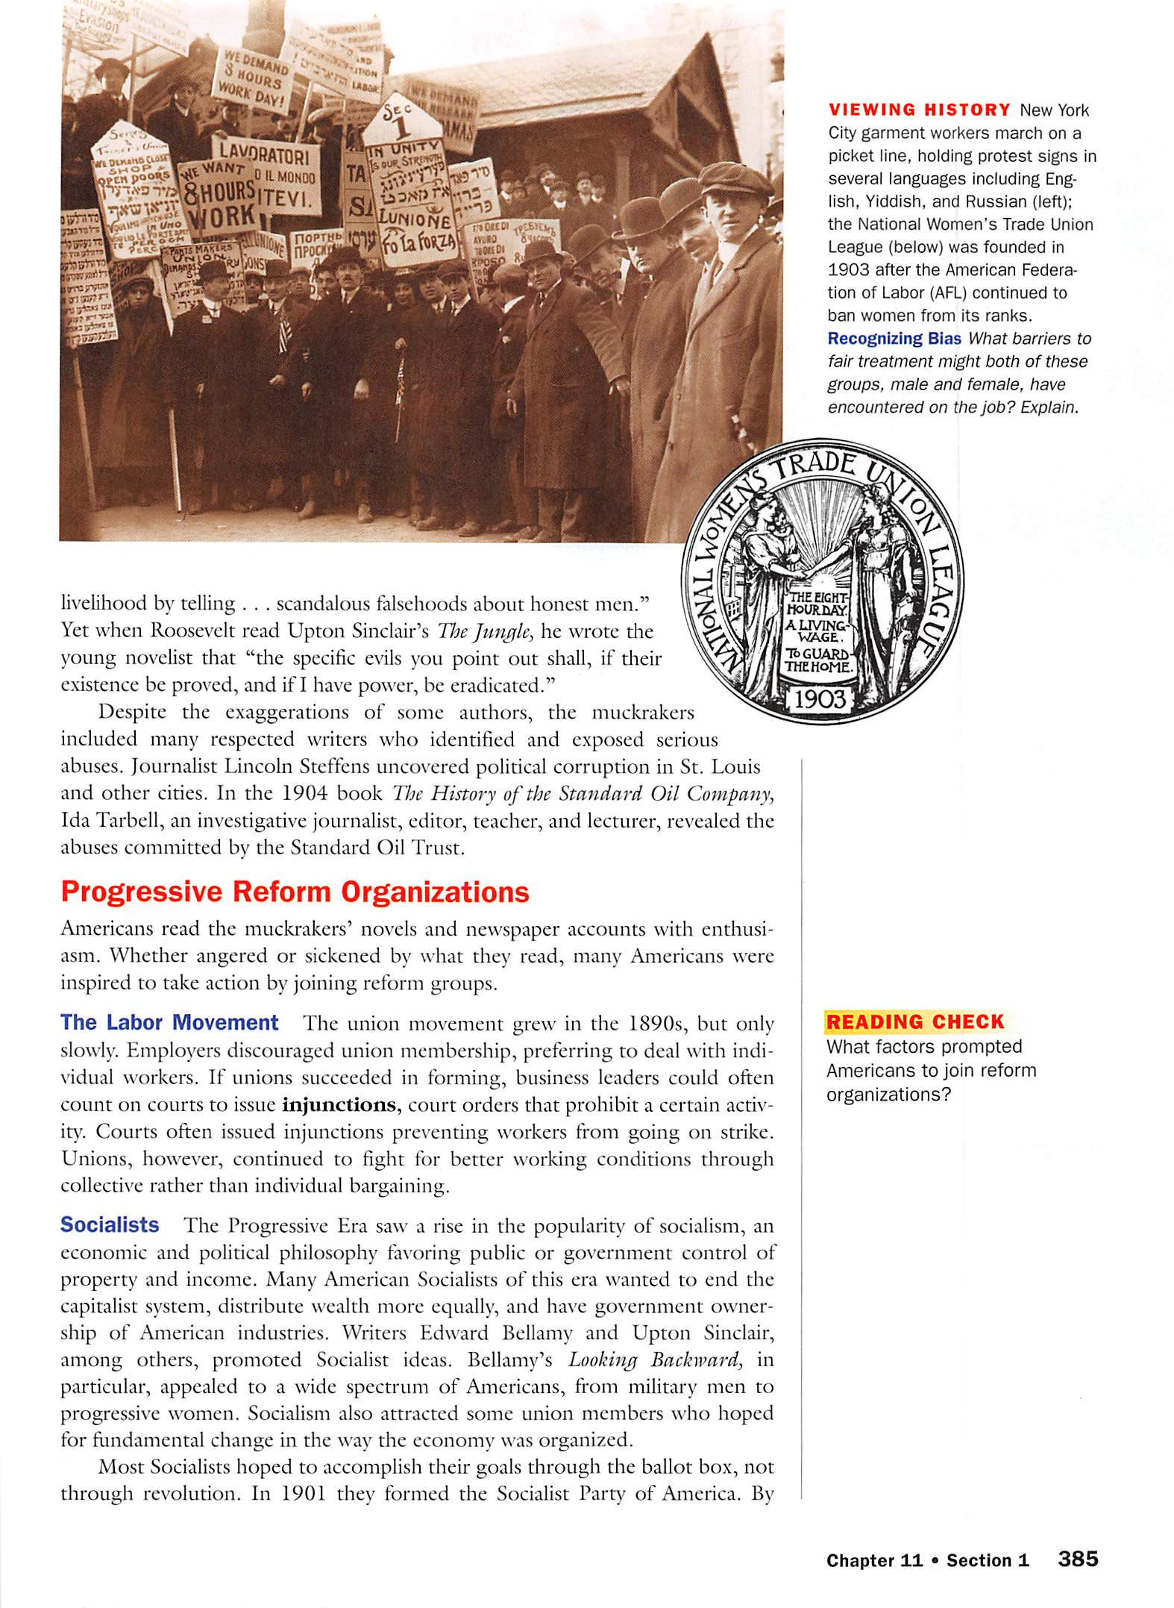

Federal Reforms and Theodore Roosevelt
A number of important Progressive reforms were made at the federal level. Beginning with Theodore Roosevelt in 1901, the White House became a powerful voice for change. In a major expansion of federal authority, Roosevelt used his presidential powers vigorously in domestic matters.

The Square Deal
Roosevelt had been proven reformer causing many Republican leaders and “Big Business” tycoons to become annoyed with him. They convinced William McKinley to choose Roosevelt as his running mate, thinking that ______________ _________________________________________________________________________________________________
_________________________________________________________________________________________________After serving only a few months as Vice-President under President McKinley, however, McKinley is assassinated making Roosevelt the 26th President of the United States. Roosevelt used the office of POTUS to push reform proposals and expand the power of the office of the POTUS.
  - Roosevelt’s reform program was called the Square Deal and its _________________________________________________________________________________________________________________________________________________________________________________
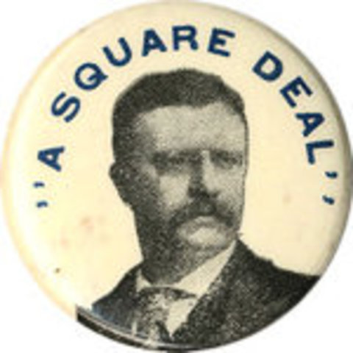

The Square Deal consisted of the “Three C’s”

____________________________, ___________________________, and ____________________________

1.____________________________________________
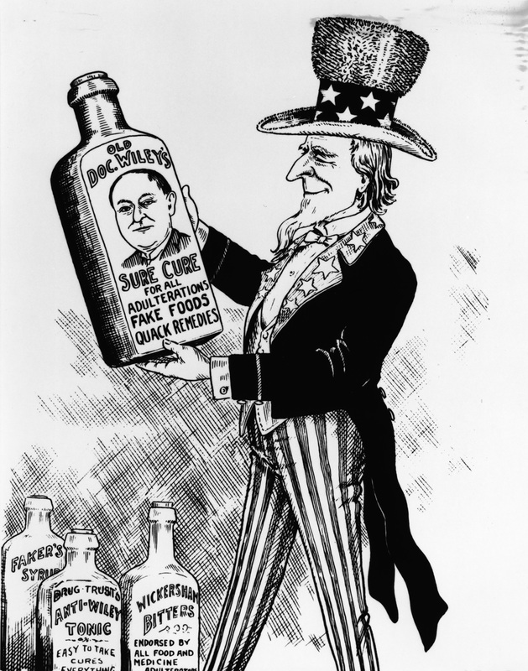

      - After reading ___________________________, Roosevelt passes the Meat Inspection Act and the Pure Food and Drug Act of 1906
      - These ____________________________________________________ ______________________________________________________________________________________________________________________________________________________________________________
2._______________________________________
- Went after corporate monopolies earning a reputation as a “________________________________” by _______________________________________________________________________________ in the railroad, meat, and sugar industries.

3. ________________________________________
- Feared the US might be steamrolled by the Industrial era’s ___________________________________ for ____________________________ and _______________________________
- Identifies ___________________________________ as public land, including ____________________, ________________________________________, and ______________________________________.

  - As President from 1901 to 1909, he signed legislation five national parks: Crater Lake, Oregon;
Wind Cave, South Dakota; Sullys Hill, North Dakota (later re-designated a game preserve); Mesa Verde, Colorado; and Platt, Oklahoma (now part of Chickasaw National Recreation Area).
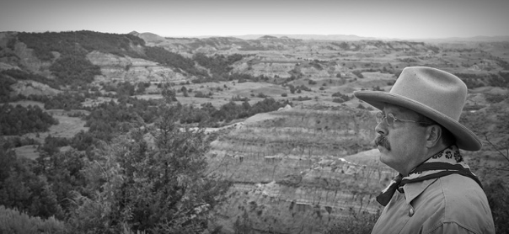

Additional Information
Roosevelt serves two terms as POTUS (1901-1909), and he promised after reelection in 1904 that he would not run again; however, after his successor, William Taft (27th POTUS), raised tariff duties and opened some public lands for development, Roosevelt became outraged and threw his hat into the ring for the election of 1912 as a presidential candidate for the newly formed Progressive Republican Party. However, this caused republican votes to split and _____________________________________________ wins the election.
Woodrow Wilson
Served as 28th POTUS from 1913-1921

*Our study of President Wilson will consist of two parts. Part one will consist of his early life and his role as a Progressive leader. Part two will discuss his role during and after World War I.

PART ONE
Before the Presidency

Woodrow Wilson was the son of a Presbyterian minister. He graduated from Princeton and studied law at the University of Virginia, abandoning his law career after two years to study history and government eventually earning a Ph.D. from John Hopkins University (He is the only president to have earned a Ph.D.) In 1902 he was the unanimous choice to become president of Princeton.

Wilson left the academic world in 1910 after he received the ___________________________________
_________________________________________________________________. He won the election
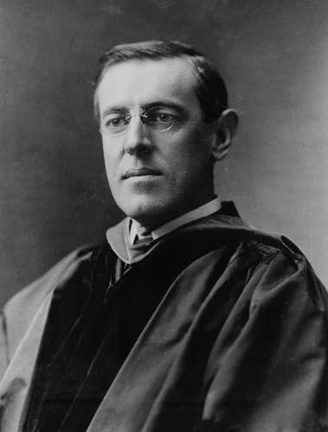

becoming the 34th governor of New Jersey.

Wilson entered the presidential race in 1912, prevailing after Roosevelt and Taft split the
Republican votes. Woodrow Wilson became the 28th President of the United States- the first
Southern-born president elected since the Civil War.

In his campaign, Wilson answered Roosevelt’s call for a “New Nationalism” with his own equally
compelling vision of a “_________________________________________.”

Wilson’s New Freedoms

Wilson outlined his aim ________________________________________________________ – more freedom – for small businesses. He attacked what he called the “__________________________________________________” that blocked businesses from being free. The “triple wall of privilege” consists of

(1)_________________________, (2)______________________, and (3)_____________________.

Wilson made significant victories as President. He won his first victory with passage of the Underwood-Simmons Tarriff (1913), which _________________________________________________for the first time in 40 years. Accompanying the new tariff, to offset lost revenues, was an ______________________________, which was permitted under the recently adopted Sixteenth Amendment to the Constitution.
Wilson’s second victory came when, after months of months of complicated debates and bargaining over banking and currency reform, Congress in 1913 passed the act creating the________________________________________________, which remains ______________________________________________________________ in economic affairs.
The _____________________________ (1913) placed national banks under control of a Federal Reserve Board, which set up regional banks to hold reserve funds from commercial banks. Still in place today, this system helps protect the American economy ________________________________________ end up in the hands of one __________, _____________, or _____________. The Federal Reserve also sets interest rates and supervises banks to make sure they are well run.
A third victory came with passage of the _____________________________________ (1914), which strengthened existing laws against anticompetitive business actions and gave labor unions relief from court injunctions. Accompanying this act was the _________________________________________________, which created the Federal Trade Commission, a major agency overseeing business practices. (previously discussed in this handout)
Wilson also worked to pass the ___________________________________________ (1916) and __________________ ______________________________________________.
Progressive Amendments to the US Constitution

Progressive Reformers successfully influenced the passage of much substantive legislation, including four Amendments to the US Constitution.

The 16th Amendment (Ratified in 1913)

        - ____________________________________________________________________________

The 17th Amendment (Ratified in 1913)

        - _____________________________________________________________________________
_____________________________________________________________________________
        - The 17th Amendment altered the electoral mechanism established in Article I, Section 3, of the Constitution, which had provided for the appointment of senators by the state legislatures.

The 18th Amendment (Ratified in 1919)
        - emerged from the organized efforts of the temperance movement which attributed alcohol to virtually all of society’s ills
        - ____________________________________________________________________
____________________________________________________________________
        - It was repealed in 1933, following the ratification of the Twenty-first Amendment.

The 19th Amendment (Ratified in 1920)

        - __________________________________________________________________________________

Progressivism Leaves a Lasting Legacy

- The federal government grew to offer more protection to American’s private lives.
- The American economy showcased the strength of the Progressive’s legacy.
- The Progressive helped to expand the government’s role in managing natural resources.
- Progressive reforms provided much needed consumer protections.

